**Aaaasssssssssss**

**A Project Report**

**On**

**Recruiting Assistance For The HR Managers**

**Using Salesforce**

**Submitted by the team:-**

Team ID : LTVIP2023TMID08760

Team Size : 5

Team Leader : Chandrakalavathi Devireddy

Team member : C Kusuma

Team member : B.Chandanasree

Team member : M Pavithra

Team member : J.Akhilandeswaraiah

**CONTENTS**

|  |
| --- |
| **S.No Table of Contents Page.No**  **1 . INTRODUCTION**  **1.1 Overview 3**  **1.2 Purpose**  **2. LITERATURE SURVEY**  **2.1 Existing Problem 3-4**  **2.2 Proposed Solution**  **3. THEORETICAL ANALYSIS**  **3.1 Block diagram 5-6**  **3.2 Hardware/Software designing**  **4. RESULT 6-14**  **5. ADVANTAGES & DISADVANTAGES 15**  **6. APPLICATIONS 16**  **7. CONCLUSION 16-17**  **8. FUTURE SCOPE 17-18** |

**1. INTRODUCTION**

**1.1 Overview:-**

**Recruitment is a critical function for any organization, and HR managers often face challenges in managing large volumes of applicants while maintaining a postitive candidate experience.To address these challenges, this project is focused to make the existing app more efficient for the HR team we create custom objects and relationships to store and access the data more efficiently. We install an unmanaged package in the org to get metadata that acts as existing data in the recruiting app. And also we create Custom objects, tabs, Fields& Relationships, Page Layouts, Validation Rules, Profiles, Users, Permission Sets, Reports and Dashboards.**

**1.2 Purpose:-**

**The purpose of this project was to develop and implement a comprehensive recruiting assistance system for HR managers using salesforce, a powerful customer relationship management(CRM) platform.The primary objective was to empower HR teams with a comprehensive and adaptable suggestion that enhances recruitment processes delivers a positive candidate experience and enables data driven decision making by leveraging the capabilities of sales force organizations can attract and hide the right talent efficiently contributing to their success and competitiveness in the job market.**

**2. LITERATURE SURVEY**

**2.1 Existing Problem:-**

1. **Integration Complexity: Implementing a recruiting assistance solution within Salesforce might require integrating with existing HR systems,such as applicant tracking systems(ATS) or human resource information systems(HRIS). Integration challenges can arise,leading to data discrepancies, Synchronization issues, or even system downtime.**
2. **Data Privacy and Security: Recruitment involves handling sensitive candidate information. Ensuring data privacy and security is paramount, especially when utilizing a cloud-based platform like Salesforce. Organizations need to implement robust security measures and comply with relevant data protection regulations.**
3. **Scalability: Organizations experiencing rapid growth might find it challenging to scale their Salesforce recruiting solution accordingly. Ensuring that the platform can handle increased data volume and user traffic is critical for continued success.**
4. **Lack of Specialized HR Functionality: Salesforce is primarily a customer relationship management(CRM) platform, and while it can be customized for HR purposes, it may not have all the specialized features that dedicated HR software offers.**

**2.2 Proposed Solution:-**

1. **Integration Strategy: Develop a robust integration strategy to connect Salesforce with existing HR systems like ATS or HRIS. Ensure seamless data flow and synchronization between systems to avoid discrepancies and data issues.**
2. **Data Privacy and Security Measures: Implement strong security measures to protect candidate data and comply with data protection regulations. Regularly audit security controls and keep abreast of best practices in data security.**
3. **Scalability Planning: Anticipate future growth and scalabilty needs while designing the recruiting assistance solution. Ensure that the platform can handle increased data volume and user traffic without compromising performance.**
4. **Regular Performance Monitoring and Maintenance: Continuously monitor the performance of the recruiting solution and address any issues promptly. Regularly update the system to take advantage of new features and improvements.**

**3. THEORETICAL ANALYSIS**

**3.1 Block diagram:**

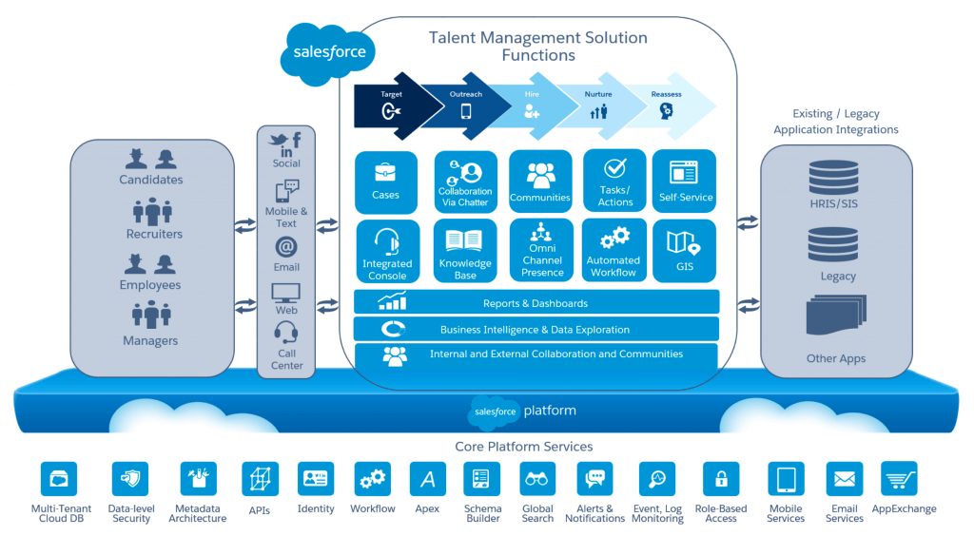

**The above is a typical Service Cloud and Community Cloud Configuration for recruiting.**

**3.2 Hardware/Software designing:-**

**To provide recruiting assistance for HR managers using Salesforce, we need necessary hardware and software requirements for implementing and using Salesforce’s features effectively. Here are the typical hardware and software requirements:**

**Hardware Requirements:**

1. **Computer: A modern computer with sufficient processing power and memory to handle Salesforce and other applications smoothly.**
2. **Internet Connection: A satble and reliable internet connection is essential for accessing and using Salesforce cloud-based services.**

**Software Requirements:**

1. **Salesforce CRM: An organization with salesforce CRM license that includes access to the necessary recruiting features. The specific features might be available in different editions.**
2. **Web Browser: Salesforce is a cloud-based platform and is accessible through web browsers, should have up-to-date web browser like Google Chrome, Mozilla, Firefox, Microsoft Edge etc..**
3. **Operating System: Salesforce is web-based and can be accessed from various operating systems including Windows, macOs, and Linux.**
4. **Salesforce AppExchange: The AppExchange is an online marketplace where you can find and isntall various third-party applications that integrate seamlessly with Salesforce.**

**4. RESULT**

**The outputs for the tasks of the project are given below:**

**Fig: Salesforce Login**

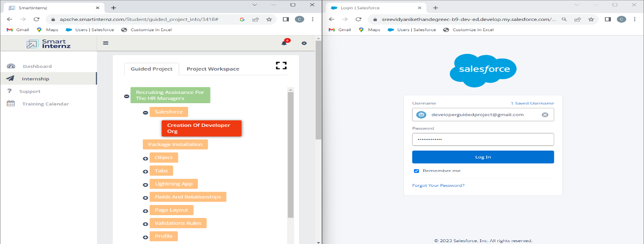

**Fig: Package Installation**

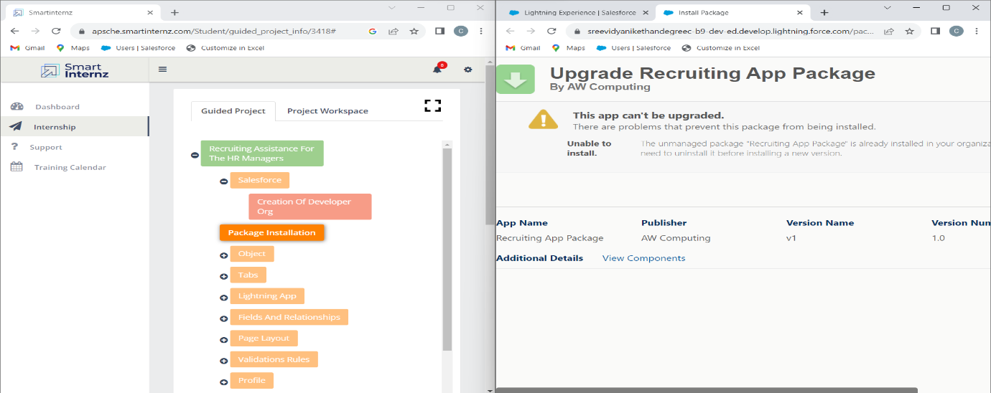

|  |  |
| --- | --- |
| **Fig: Created Custom object - Job Posting Site** |  |

**Fig: Created Custom object - Review**

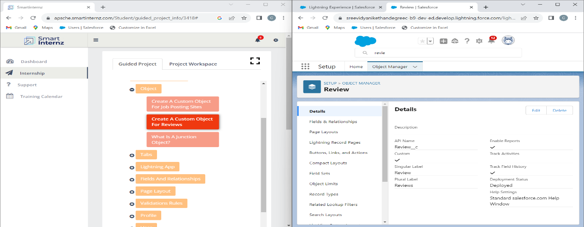

**Fig: Created Custom object - Job Posting**

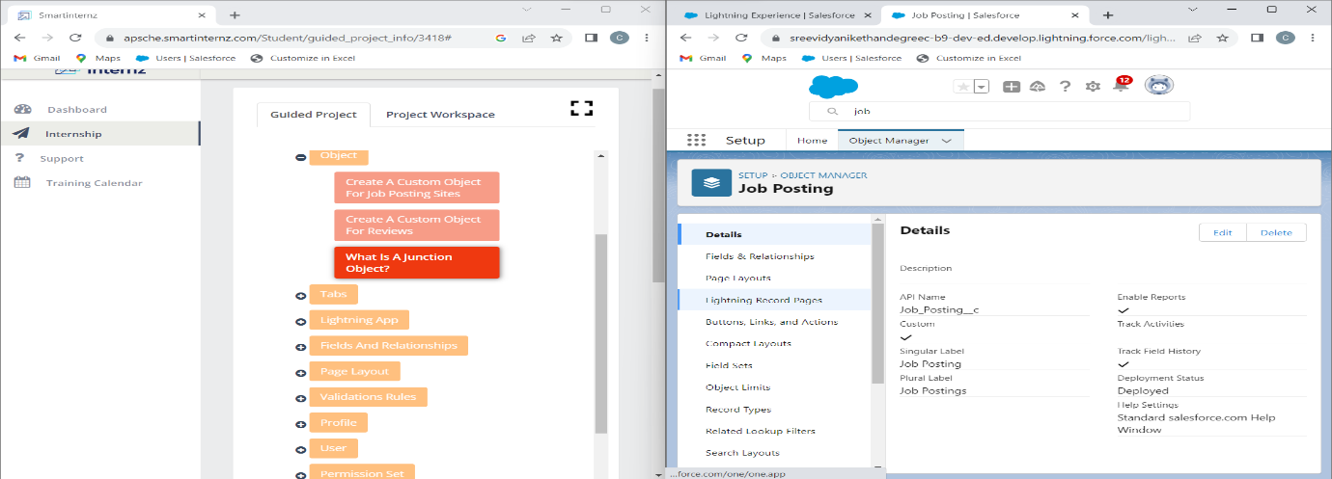

**Fig: Created Job Posting Sites Tab**

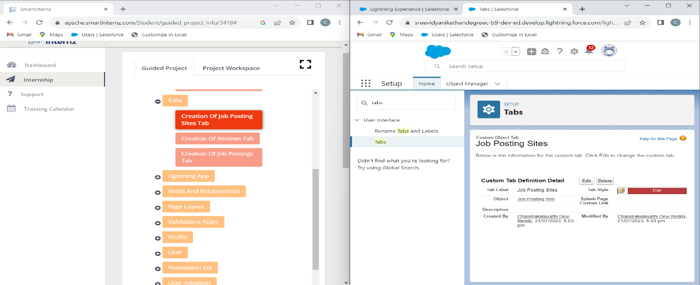

**Fig: Created Reviews Tab**

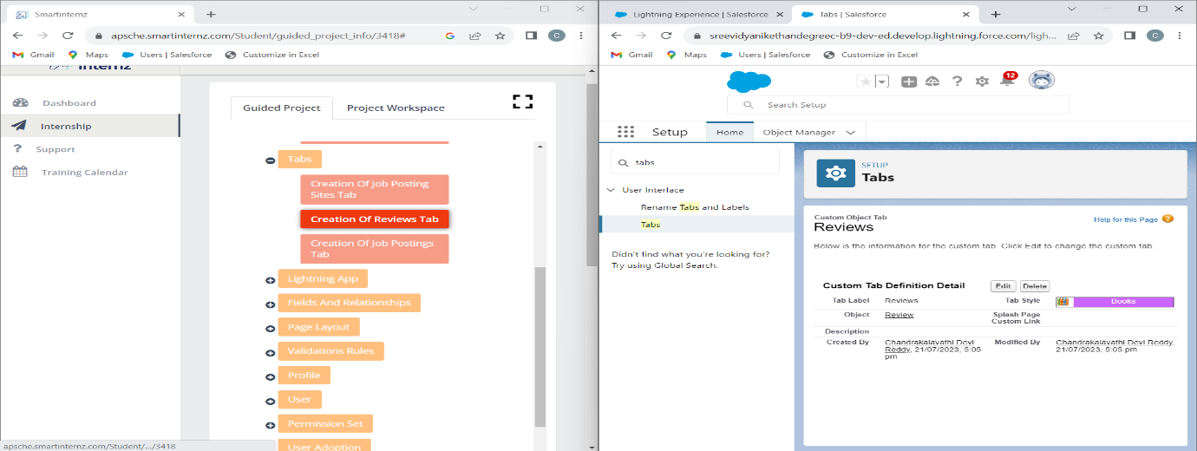

**Fig: Created Job Postings Tab**

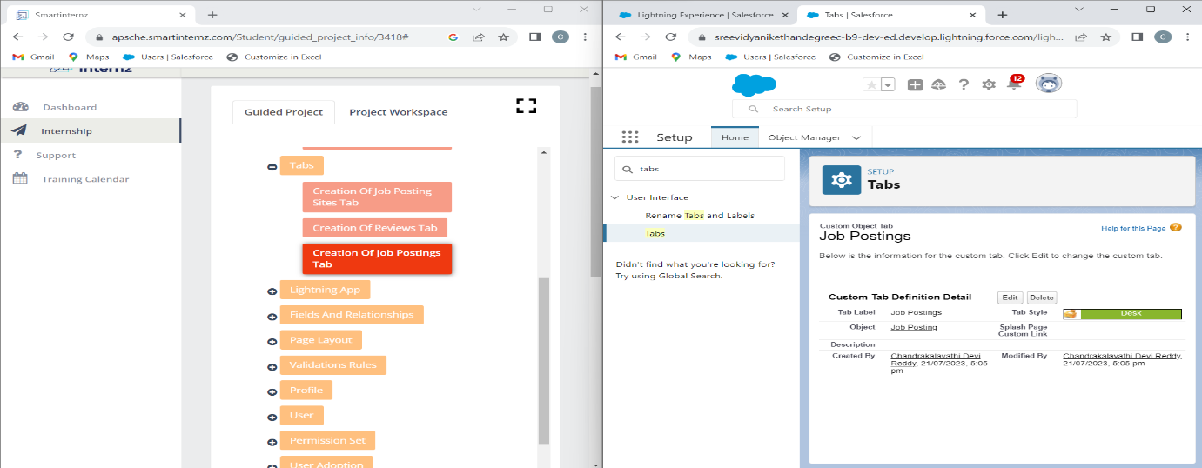

**Fig: Added Job Posting Sites Tab to Recruiting App**

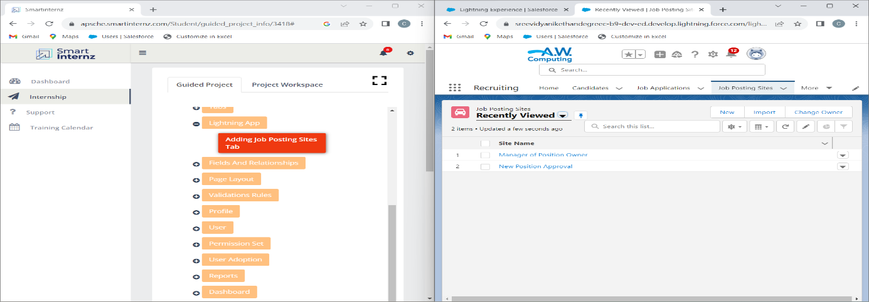

**Fig: Created new field for Job Posting Sites Object**

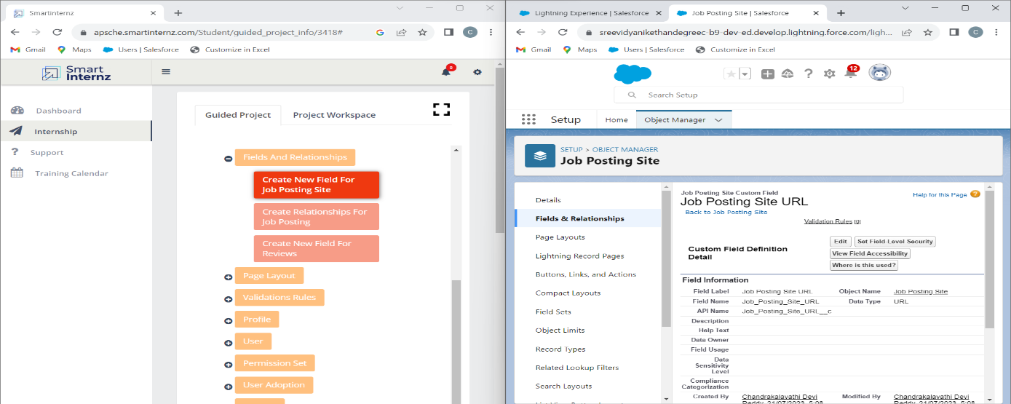

**Fig: Created new field for Job Posting Object**

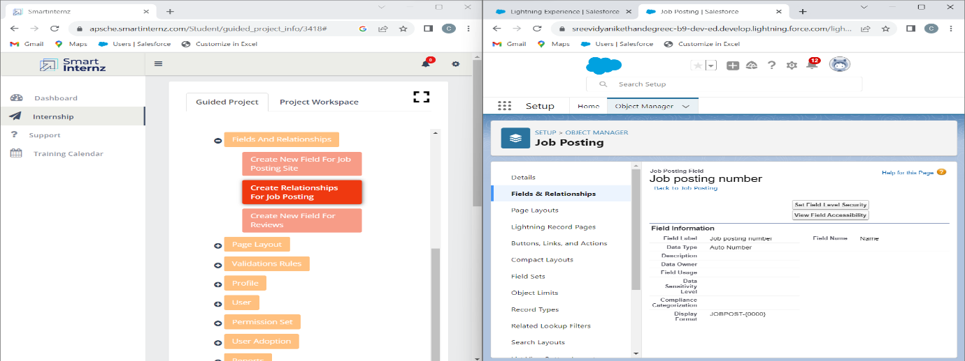

**Fig: Created new field for Reviews Tab**

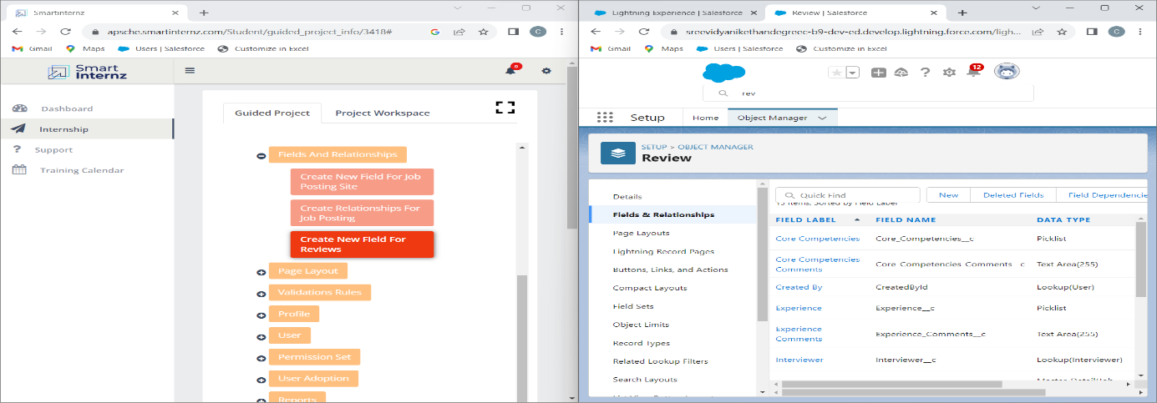

**Fig: Modified Page Layout for Position Object**

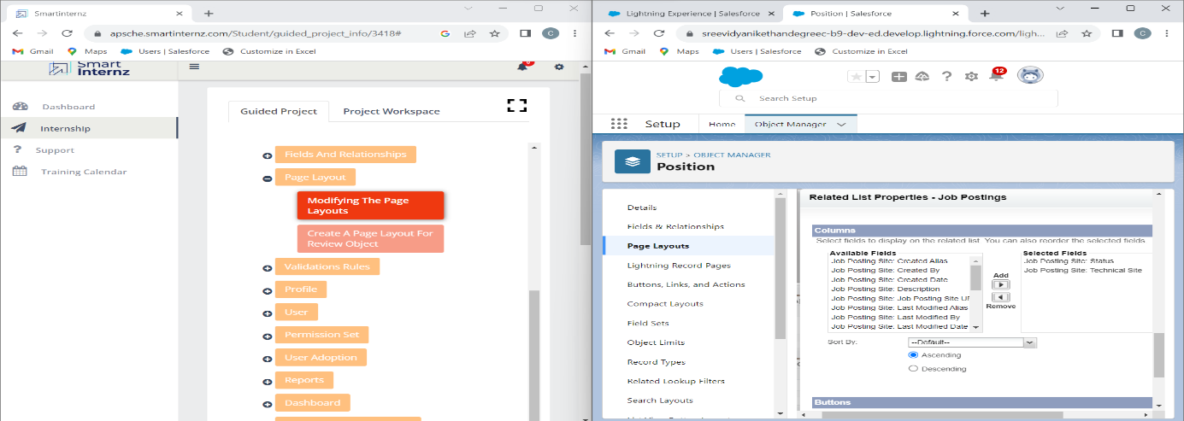

**Fig: Created Page Layout for Review Object**

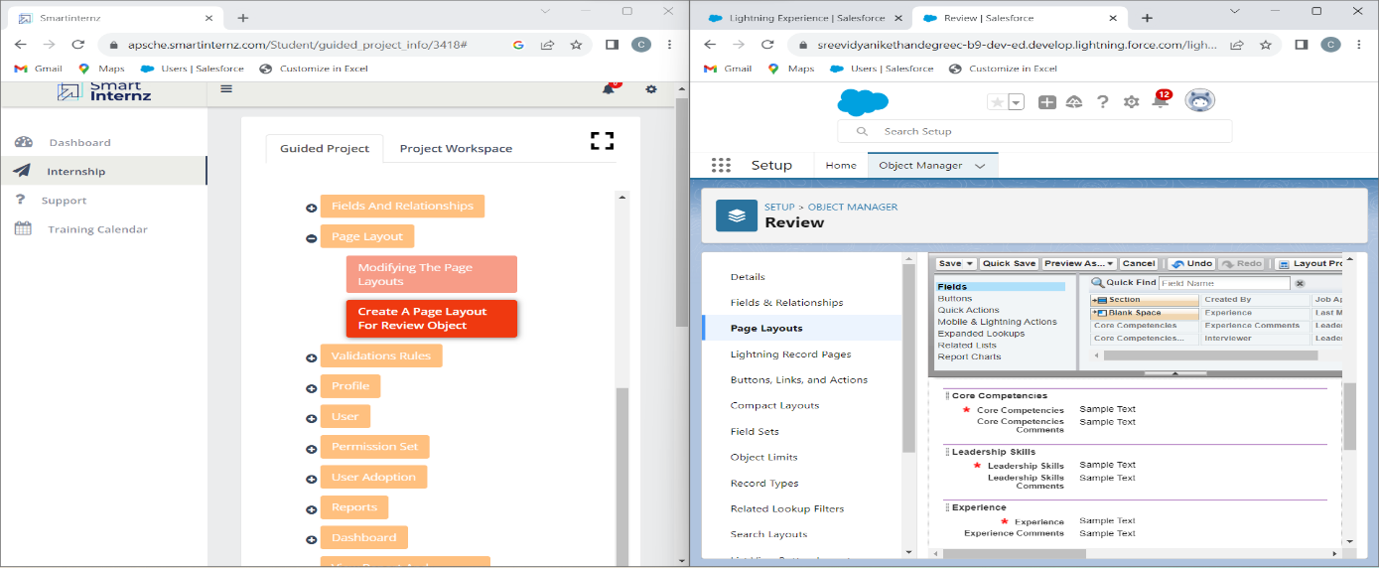

**Fig: Created new Validation Rule for Candidate object**

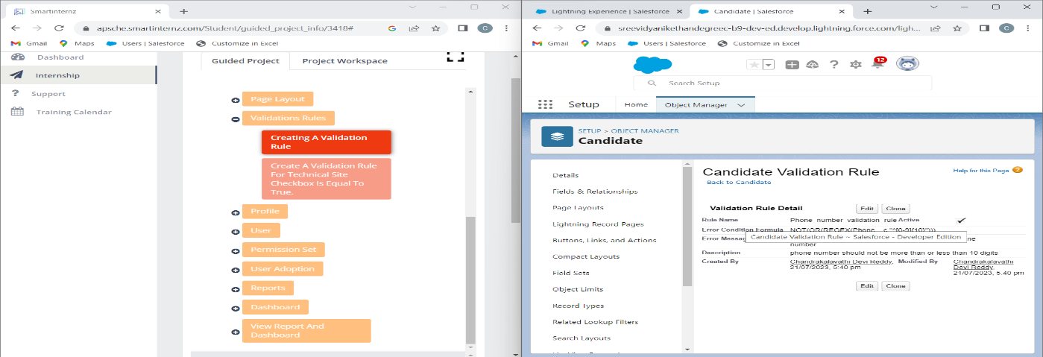

**Fig: Created Validation Rule for Job Posting Site object**

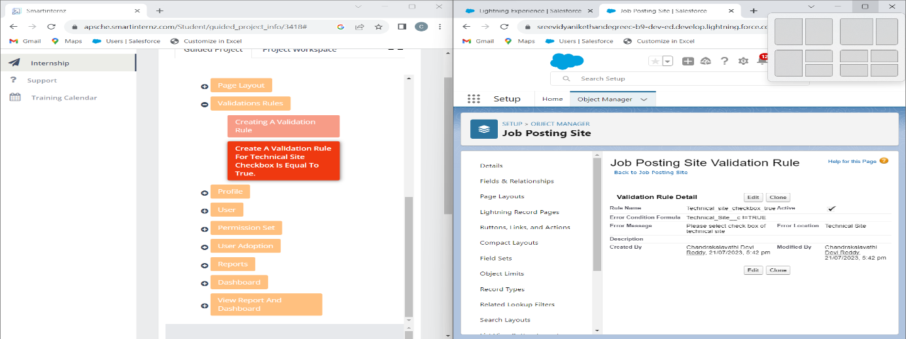

**Fig: Created a new profile - Event user profile**

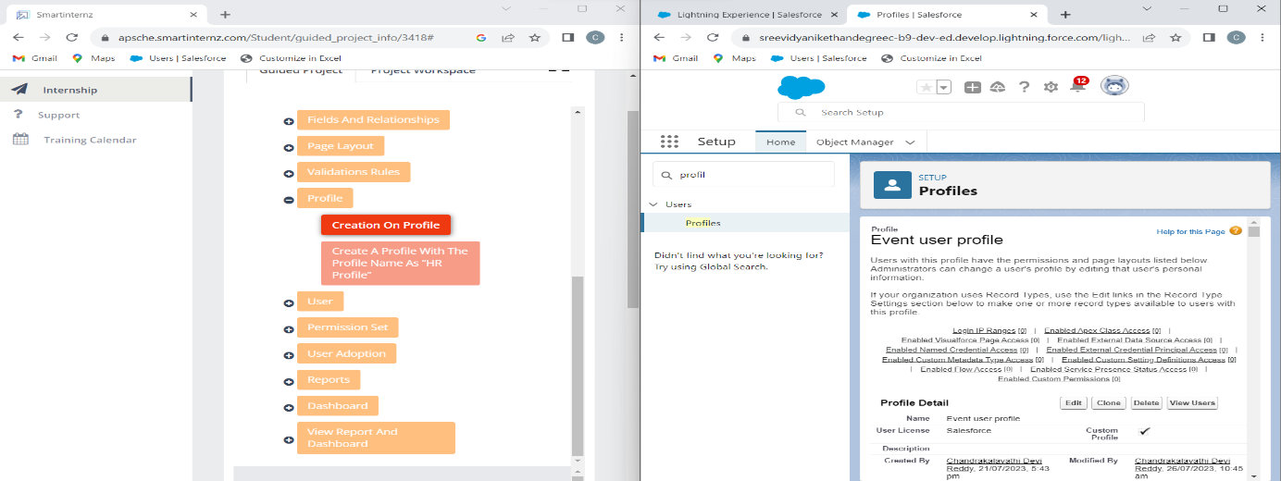

**Fig: Created a new profile - HR Profile**

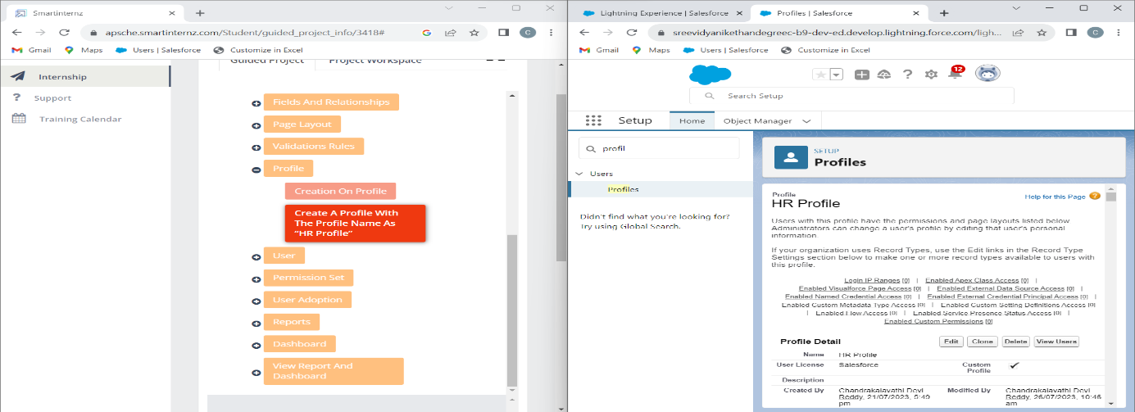

**Fig: Created a new User - Sanjay Gupta**

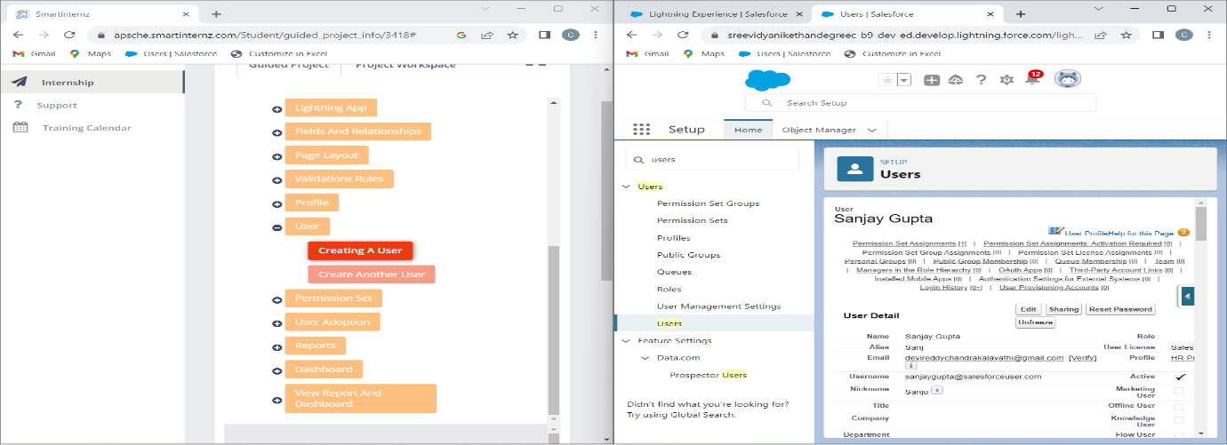

**Fig: Created a new User - Abhilash Garapati**

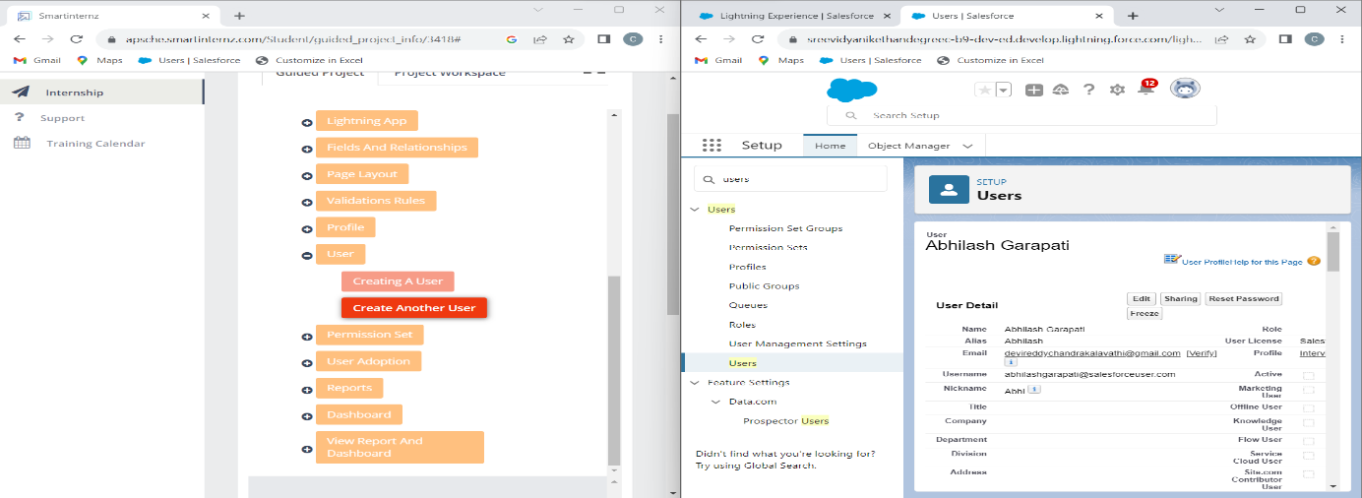

**Fig: Created Permission Set - HR Recruiter**

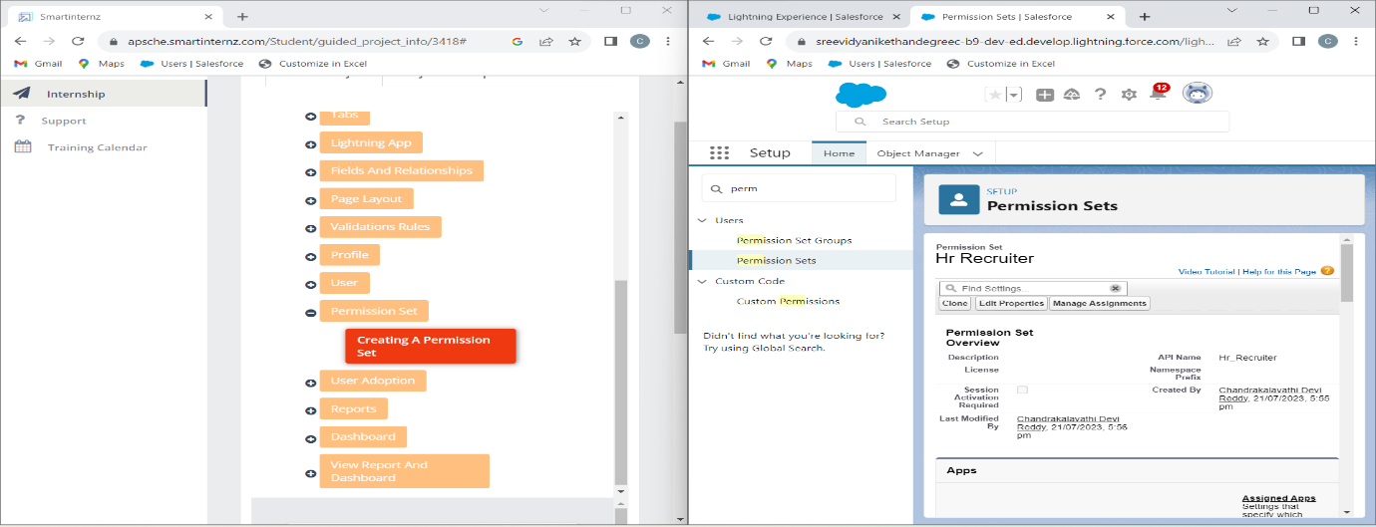

**Fig: Created, View, and deleted records for Positions in Recruiting App**

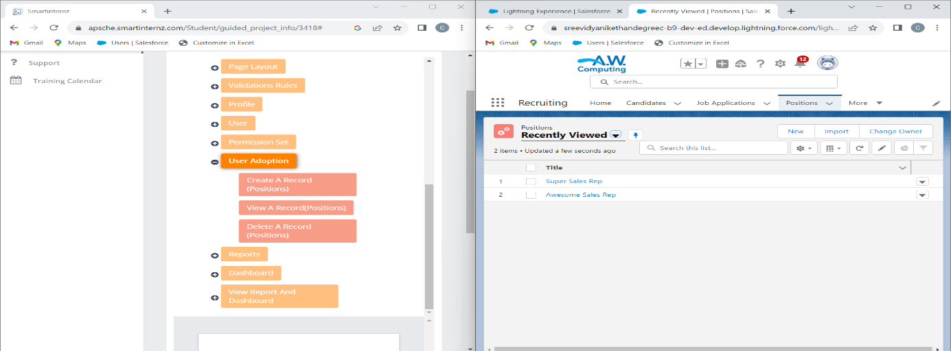

**Fig: Created a new Report - Job Application with Position**

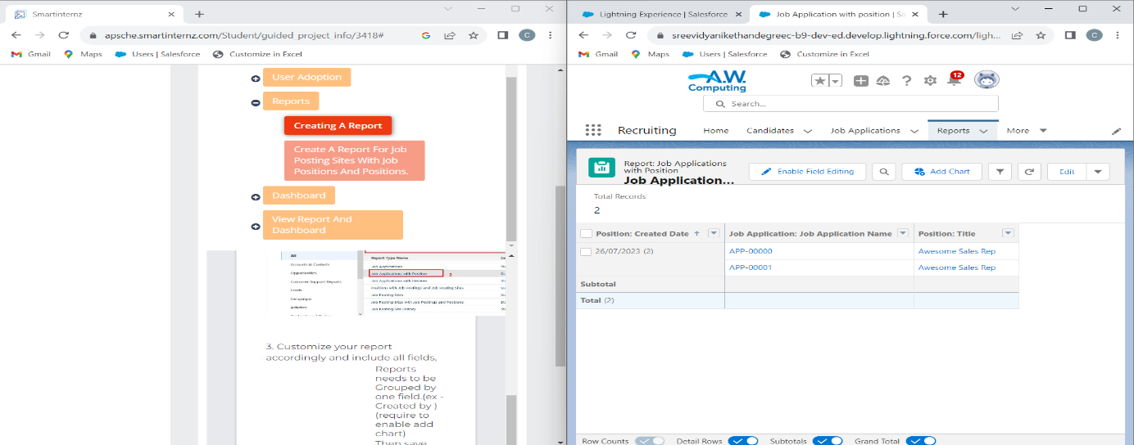

**Fig: Created a new Report - Job Posting Sites with Job Postings and Positions**

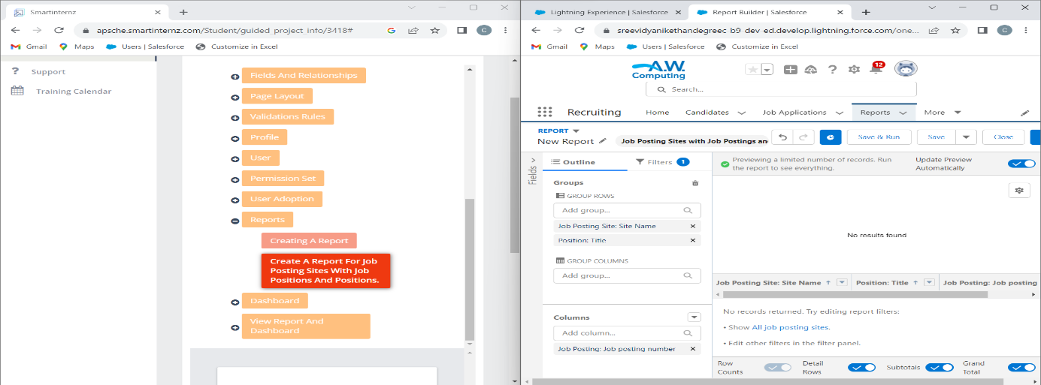

**Fig: Created a Dashboard - Job Application with Position**

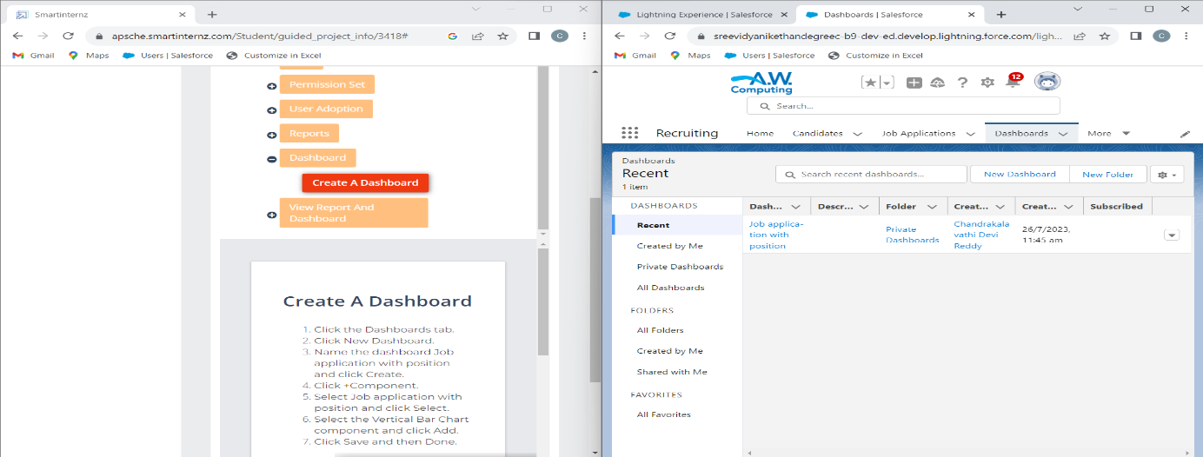

**Fig: Viewed Reports and Dashboards in Recruiting App**

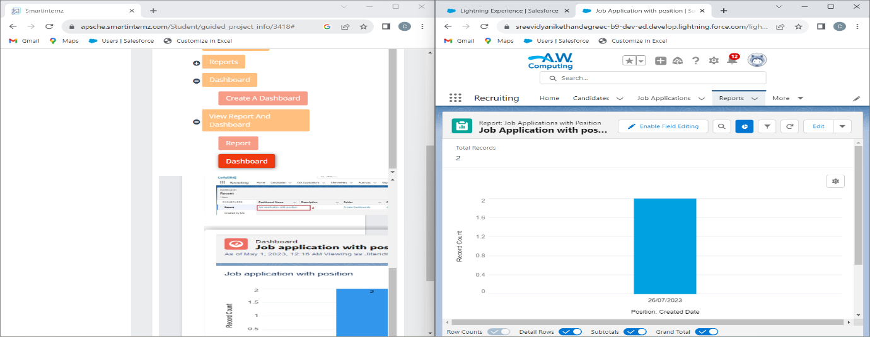

**5. ADVANTAGES & DISADVANTAGES**

**The following are the advantages and disadvantages of the proposed solutions:**

**ADVANTAGES:-**

1. **Streamlined HR Processes: Through planning and customisation based on HR requirements will lead to streamlined and efficient HR processes. Salesforce automation capabilities can reduce manual tasks and save time.**
2. **Enhanced Security and Compliance: robust security measures ensure that candidate data is protected from unauthorized access and potential breaches, promoting compliance with data protection regulations.**
3. **Scalability and Flexibility: Proper planning for scalability ensures that the solution can accommodate the organization’s growth without major disruptions.**
4. **Continuous Improvement and Innovation: regularly updating and refining the system based on feedback and new features ensures that the solution stays relevant and competitive.**

**DISADVANTAGES:**-

1. **Initial Implementation Complexity:** Implementing the solutions might be complex and the time consuming especially when integrating with existing HR systems and conducting through customization.
2. **Data Privacy and Compliance Risks:** Despite robust security measures there is always a risk of data breaches and compliance violations, especially when handling sensitive candidate information.
3. **User Resistance and Training Time:** HR managers and staff may resist the change and require significant training time to adapt to the new system which can affect productivity during the transition phase.
4. **Lack of Specialized HR Features:** salesforce might lack certain specialized HR features that dedicated HR Software offers limiting the full range of HR capabilities.

**6.APPLICATIONS**

The solutions for these challenges in recruiting assistance for HR managers using Salesforce can be applied to various areas within the HR recruitment process. Here are the key areas where these solutions can be implemented:

1. **Candidate Sourcing and Tracking:** Sales force can be customized to help HR managers source candidates from different channels track their progress through the recruitment pipeline and manage interactions with potential candidates.
2. **Candidate Engagement and Communication:** Salesforce communication tools can be utilized to engage with candidates effectively, providing updates, interview scheduling and feedback through the hiring process.
3. **Interview and Evaluation Management:** The platform can facilitate interview scheduling, interviewer feedback consolidation, and evaluation tracking, making the process more organized and efficient.
4. **Offer Management:** salesforce can be customized to manage job offers, salary negotiations, and candidate on boarding ensuring a smooth transition from candidate to employee.
5. **Analytics and Reporting:** Salesforce reporting and analytics capabilities can provide HR managers with insights into recruitment metrics helping them identify bottlenecks assess the effectiveness of sourcing channels and make data driven decisions.

**7.CONCLUSION**

In conclusion implementing recruiting assistance solutions for HR managers using Salesforce can bring significant benefits to organizations streamlining and enhancing the entire recruitment process however it is essential to acknowledge and address the challenges that may arise during the implementation and utilization of these solutions.

By carefully planning and customizing the Salesforce platform to meet the specific needs of HR recruitment organizations can experience streamline HR processes improved data integrity and increased user adoption through training and user friendly interfaces foster a positive user experience while robust security measures ensure data privacy and compliance with regulations.

Though there may be initial complexity in the implementation process and potential user resistance the long term advantages outweigh these challenges continuous monitoring maintenance and support are necessary for sustained success but the scalability and flexibility of the platform make it adaptable to organizational growth.

Overall leveraging sales force for recruiting assistance for HR Managers offers a powerful tool set to manage candidate sourcing selection engagement and reporting organizations can benefit from enhanced efficiency data driven decision making and improved candidate experiences by embracing these solutions and iterating on improvements organizations can build a more effective and competitive recruitment process ultimately contributing to the overall success of the business.

**8.FUTURE SCOPE**

In the future, several enhancements can be made to further improve recruiting assistance for HR managers using salesforce these enhancements could include:

1. **Candidate Assessment Tools:** Incorporate candidate assessment tools and skills tests into the platform allowing HR managers to evaluate candidates abilities directly from Salesforce.
2. **Chatbot for Candidate Support:** introduce a chart boat within the Salesforce platform to handle candidate inquiries provide application status updates answer faqs and guide candidates through the recruitment process.
3. **Video Interview Integration:** integrate video interview platforms directly into Salesforce enabling hr managers to conduct remote interviews seamlessly within the platform.
4. **Predictive Analytics for Recruitment:** Develop predictive analytics models that leverage historical data to forecast future hiring needs identify potential sourcing channels and optimize the recruitment strategy.
5. **Enhanced Reporting and Insights:** continuously improved reporting and analytics capabilities to provide HR managers with deeper insights into recruitment performance and trends enabling data driven decision making.

These enhancements can empower HR managers to be more efficient strategic and data driven in the recruitment efforts by embracing emerging technologies automating manual tasks enhancing user experiences organizations can stay at the forefront of recruitment innovation an attract top talent to fuel their growth and success.

**THE END**

**.**